Microservices With Spring Boot3 & Spring Cloud

MANDATORY HANDS ON

1). Creating Microservices for account and loan

Code:
1st Step: Account Microservice

AccountApplication.java

package com.cognizant.account;

import org.springframework.boot.SpringApplication;
import org.springframework.boot.autoconfigure.SpringBootApplication;

@SpringBootApplication
public class AccountApplication {

public static void main(String[] args) {
SpringApplication.run(AccountApplication.class, args);
}

}

AccountController.java

package com.cognizant.account.controller;

import org.springframework.web.bind.annotation.*;

import java.util.HashMap;
import java.util.Map;

@RestController
@RequestMapping("/accounts")
public class AccountController {

@GetMapping("/{number}")
public Map<String, Object> getAccountByNumber(@PathVariable String number) {
Map<String, Object> account = new HashMap<>();
account.put("number", number);
account.put("type", "That's the saving");
account.put("balance", 123456);
return account;
}
}

application.properties

spring.application.name=account
server.port=8081

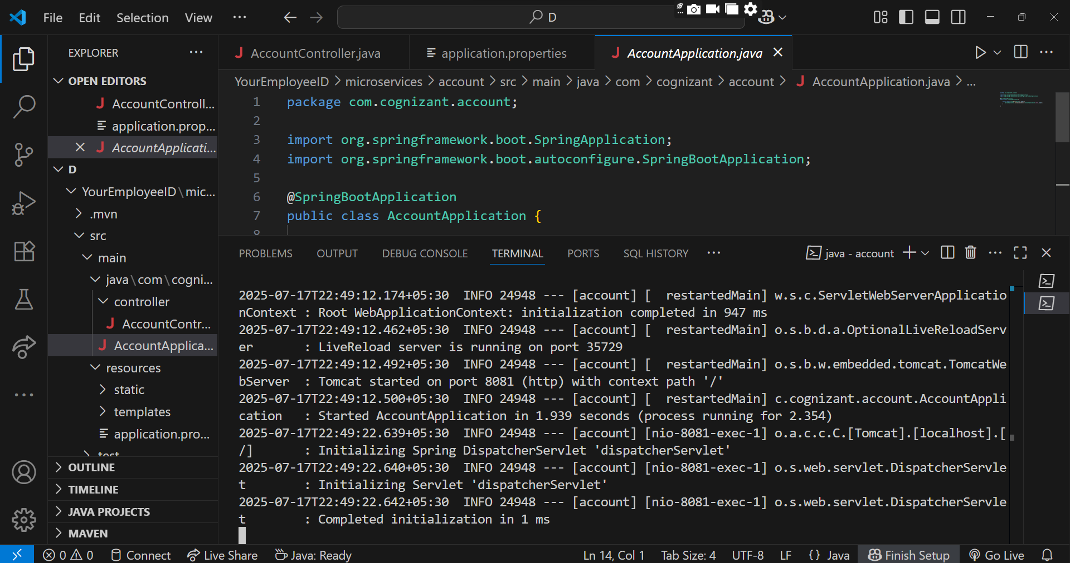

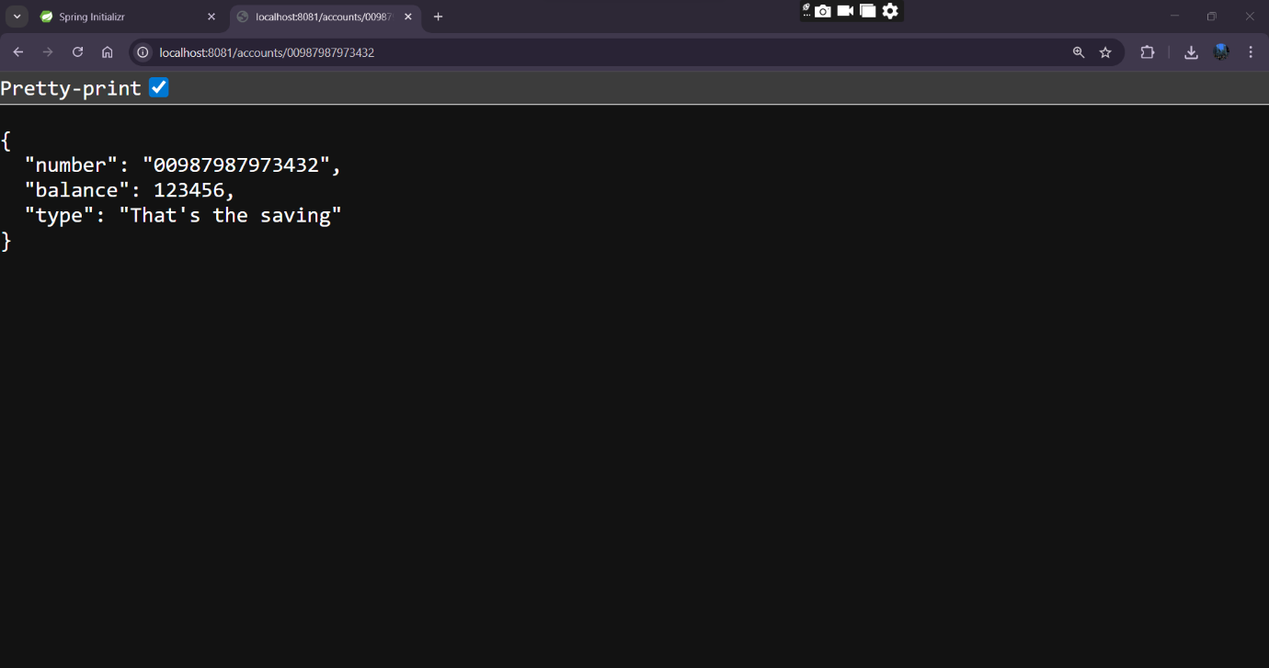

Through Postman

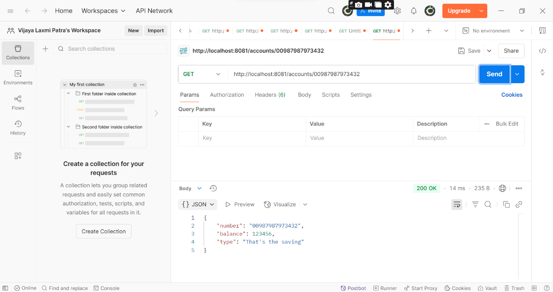

2nd Step: Loan Microservice

LoanApplication.java

package com.cognizant.loan;

import org.springframework.boot.SpringApplication;
import org.springframework.boot.autoconfigure.SpringBootApplication;

@SpringBootApplication
public class LoanApplication {

public static void main(String[] args) {
SpringApplication.run(LoanApplication.class, args);
}

}

LoanController.java

package com.cognizant.loan.controller;

import org.springframework.web.bind.annotation.*;

import java.util.HashMap;
import java.util.Map;

@RestController
@RequestMapping("/loans")
public class LoanController {

@GetMapping("/{number}")
public Map<String, Object> getLoanByNumber(@PathVariable String number) {
Map<String, Object> loan = new HashMap<>();
loan.put("number", number);
loan.put("type", "home");
loan.put("loan", 40000000);
loan.put("emi", 10876);
loan.put("tenure", 120);
return loan;
}
}

application.properties

server.port=8082
spring.application.name=loan

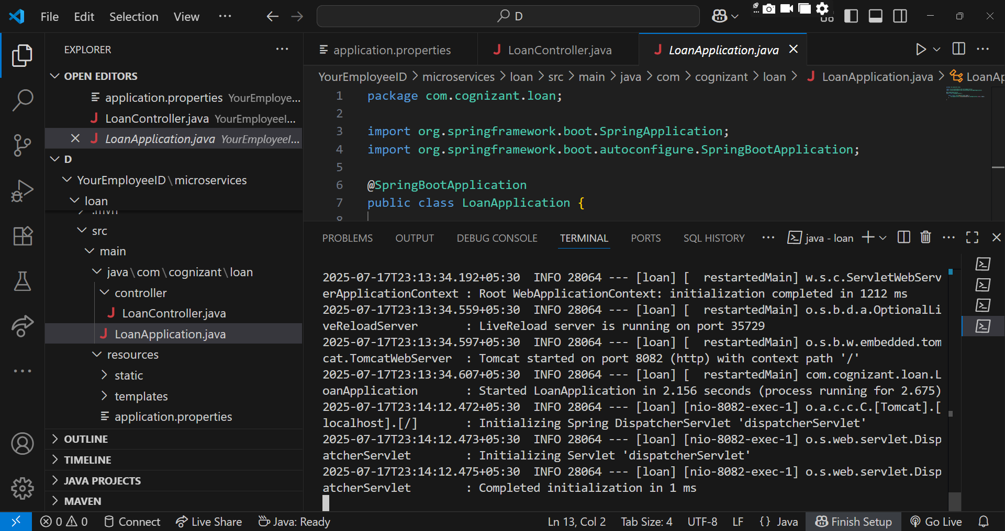

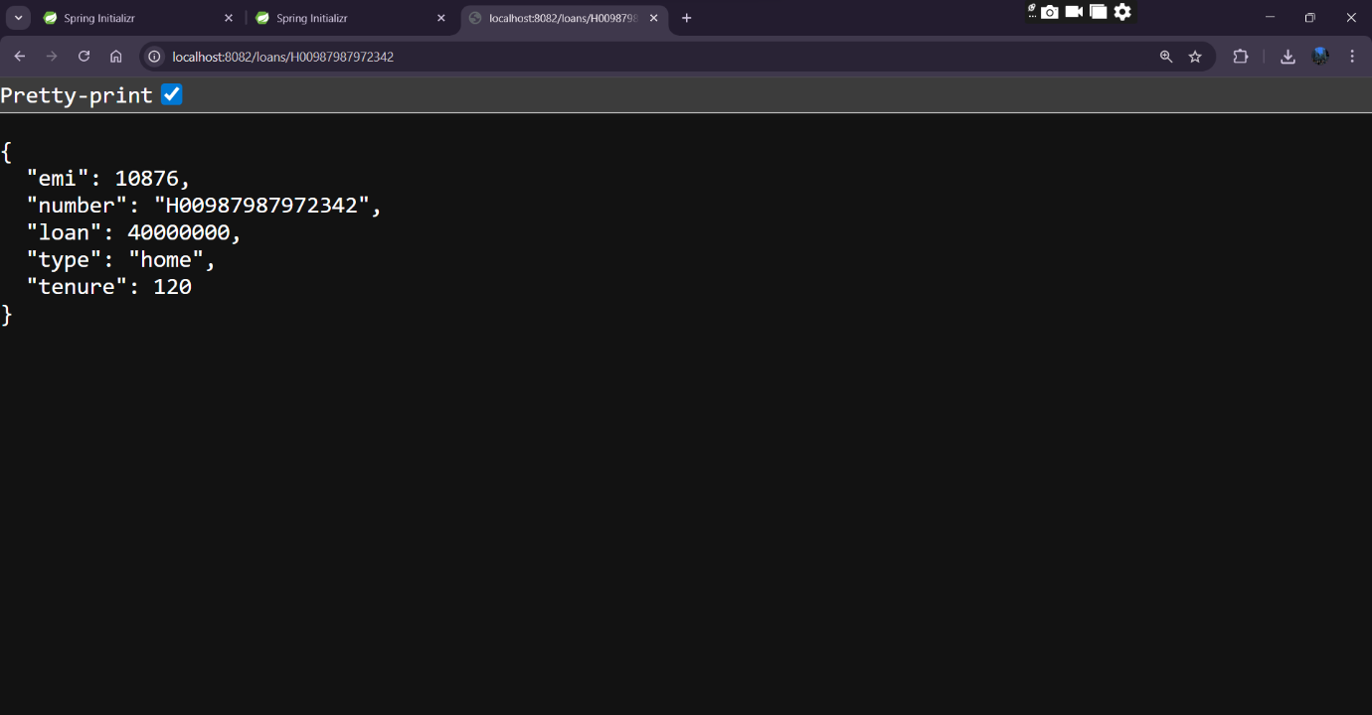

Through Postman

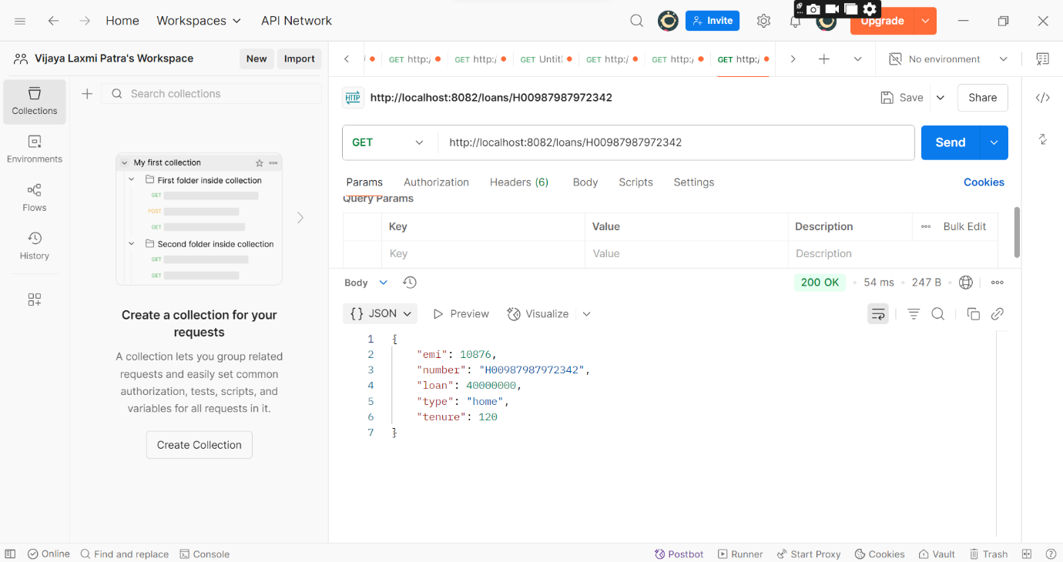

ADDITIONAL IMPORTANT HANDS ON

1). Create Eureka Discovery Server and register microservices

Code:

1st step: Eureka Server

EurekaDiscoverServerApplication.java

package com.cognizant.eureka_discovery_server;

import org.springframework.boot.SpringApplication;
import org.springframework.boot.autoconfigure.SpringBootApplication;
import org.springframework.cloud.netflix.eureka.server.EnableEurekaServer;

@SpringBootApplication
@EnableEurekaServer
public class EurekaDiscoveryServerApplication {
public static void main(String[] args) {
SpringApplication.run(EurekaDiscoveryServerApplication.class, args);
}
}

application.properties

spring.application.name=eureka-discovery-server
server.port=8761
eureka.client.register-with-eureka=false
eureka.client.fetch-registry=false
logging.level.com.netflix.eureka=OFF
logging.level.com.netflix.discovery=OFF

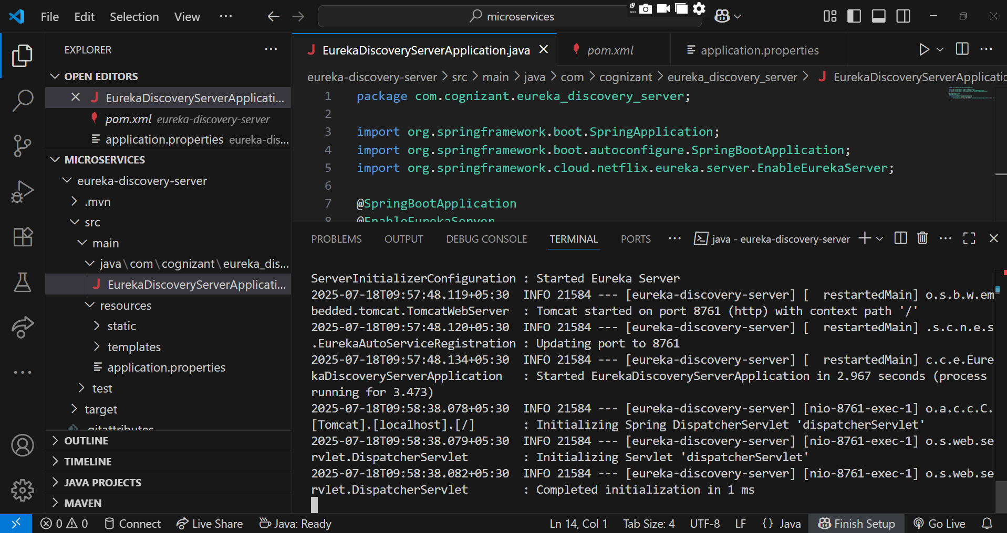

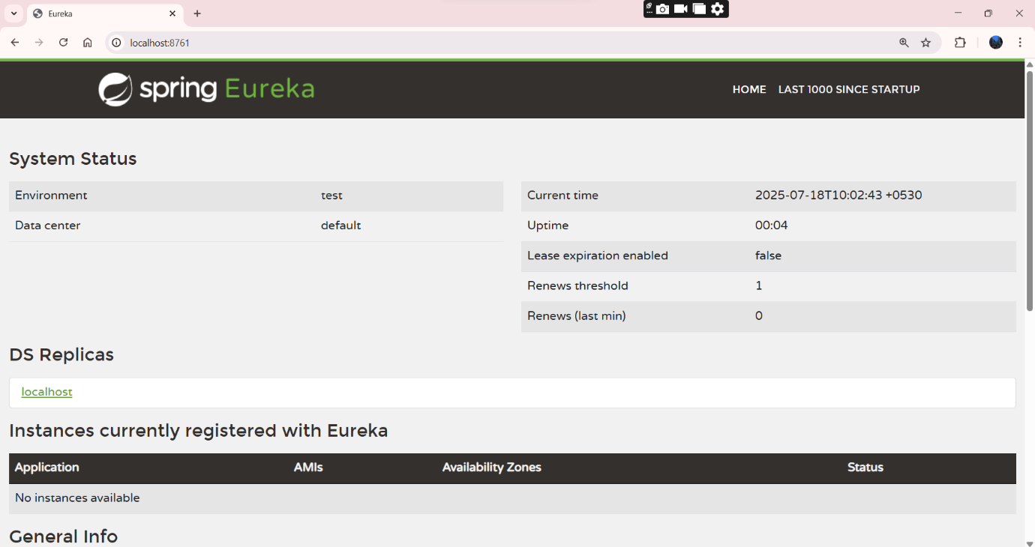

pom.xml

<?xml version="1.0" encoding="UTF-8"?>
<project xmlns="http://maven.apache.org/POM/4.0.0" xmlns:xsi="http://www.w3.org/2001/XMLSchema-instance"
xsi:schemaLocation="http://maven.apache.org/POM/4.0.0 https://maven.apache.org/xsd/maven-4.0.0.xsd">
<modelVersion>4.0.0</modelVersion>
<parent>
<groupId>org.springframework.boot</groupId>
<artifactId>spring-boot-starter-parent</artifactId>
<version>3.5.3</version>
<relativePath/>
</parent>
<groupId>com.cognizant</groupId>
<artifactId>eureka-discovery-server</artifactId>
<version>0.0.1-SNAPSHOT</version>
<name>eureka-discovery-server</name>
<description>Demo project for Spring Boot</description>
<url/>
<licenses>
<license/>
</licenses>
<developers>
<developer/>
</developers>
<scm>
<connection/>
<developerConnection/>
<tag/>
<url/>
</scm>
<properties>
<java.version>17</java.version>
<spring-cloud.version>2025.0.0</spring-cloud.version>
</properties>
<dependencies>
<dependency>
<groupId>org.springframework.boot</groupId>
<artifactId>spring-boot-starter-web</artifactId>
</dependency>
<dependency>
<groupId>org.springframework.cloud</groupId>
<artifactId>spring-cloud-starter-netflix-eureka-server</artifactId>
</dependency>

<dependency>
<groupId>org.springframework.boot</groupId>
<artifactId>spring-boot-devtools</artifactId>
<scope>runtime</scope>
<optional>true</optional>
</dependency>
<dependency>
<groupId>org.springframework.boot</groupId>
<artifactId>spring-boot-starter-test</artifactId>
<scope>test</scope>
</dependency>
</dependencies>
<dependencyManagement>
<dependencies>
<dependency>
<groupId>org.springframework.cloud</groupId>
<artifactId>spring-cloud-dependencies</artifactId>
<version>${spring-cloud.version}</version>
<type>pom</type>
<scope>import</scope>
</dependency>
</dependencies>
</dependencyManagement>

<build>
<plugins>
<plugin>
<groupId>org.springframework.boot</groupId>
<artifactId>spring-boot-maven-plugin</artifactId>
</plugin>
</plugins>
</build>

</project>

2nd Step: Account REST API

AccountApplication.java

package com.cognizant.account;

import org.springframework.boot.SpringApplication;
import org.springframework.boot.autoconfigure.SpringBootApplication;

@SpringBootApplication
public class AccountApplication {

public static void main(String[] args) {
SpringApplication.run(AccountApplication.class, args);
}

}

AccountController.java

package com.cognizant.account.controller;

import org.springframework.web.bind.annotation.*;

import java.util.HashMap;
import java.util.Map;

@RestController
@RequestMapping("/accounts")
public class AccountController {

@GetMapping("/{number}")
public Map<String, Object> getAccountDetails(@PathVariable String number) {
Map<String, Object> account = new HashMap<>();
account.put("number", number);
account.put("type", "savings");
account.put("balance", 234343);
return account;
}
}

application.properties

server.port=8087

spring.application.name=account-service

eureka.client.service-url.defaultZone=http://localhost:8761/eureka

pom.xml

<?xml version="1.0" encoding="UTF-8"?>
<project xmlns="http://maven.apache.org/POM/4.0.0" xmlns:xsi="http://www.w3.org/2001/XMLSchema-instance"
xsi:schemaLocation="http://maven.apache.org/POM/4.0.0 https://maven.apache.org/xsd/maven-4.0.0.xsd">
<modelVersion>4.0.0</modelVersion>
<parent>
<groupId>org.springframework.boot</groupId>
<artifactId>spring-boot-starter-parent</artifactId>
<version>3.5.3</version>
<relativePath/> <!-- lookup parent from repository -->
</parent>
<groupId>com.cognizant</groupId>
<artifactId>account</artifactId>
<version>0.0.1-SNAPSHOT</version>
<name>account</name>
<description>Demo project for Spring Boot</description>
<url/>
<licenses>
<license/>
</licenses>
<developers>
<developer/>
</developers>
<scm>
<connection/>
<developerConnection/>
<tag/>
<url/>
</scm>
<properties>
<java.version>21</java.version>
<spring-cloud.version>2025.0.0</spring-cloud.version>
</properties>
<dependencies>
<dependency>
<groupId>org.springframework.boot</groupId>
<artifactId>spring-boot-starter-web</artifactId>
</dependency>
<dependency>
<groupId>org.springframework.cloud</groupId>
<artifactId>spring-cloud-starter-netflix-eureka-client</artifactId>
</dependency>

<dependency>
<groupId>org.springframework.boot</groupId>
<artifactId>spring-boot-devtools</artifactId>
<scope>runtime</scope>
<optional>true</optional>
</dependency>
<dependency>
<groupId>org.springframework.boot</groupId>
<artifactId>spring-boot-starter-test</artifactId>
<scope>test</scope>
</dependency>
</dependencies>
<dependencyManagement>
<dependencies>
<dependency>
<groupId>org.springframework.cloud</groupId>
<artifactId>spring-cloud-dependencies</artifactId>
<version>${spring-cloud.version}</version>
<type>pom</type>
<scope>import</scope>
</dependency>
</dependencies>
</dependencyManagement>

<build>
<plugins>
<plugin>
<groupId>org.springframework.boot</groupId>
<artifactId>spring-boot-maven-plugin</artifactId>
</plugin>
</plugins>
</build>

</project>

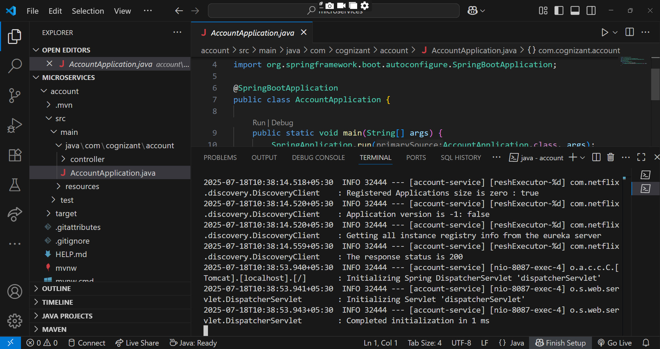

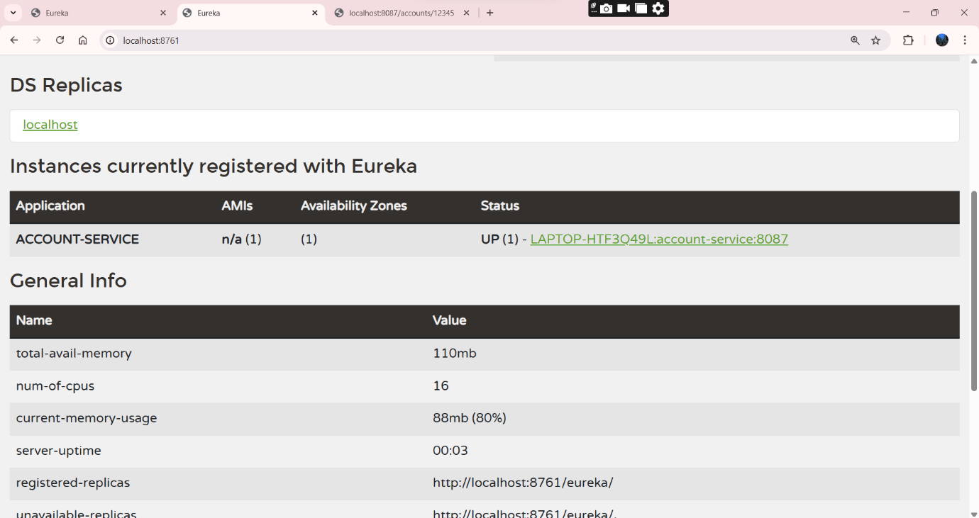

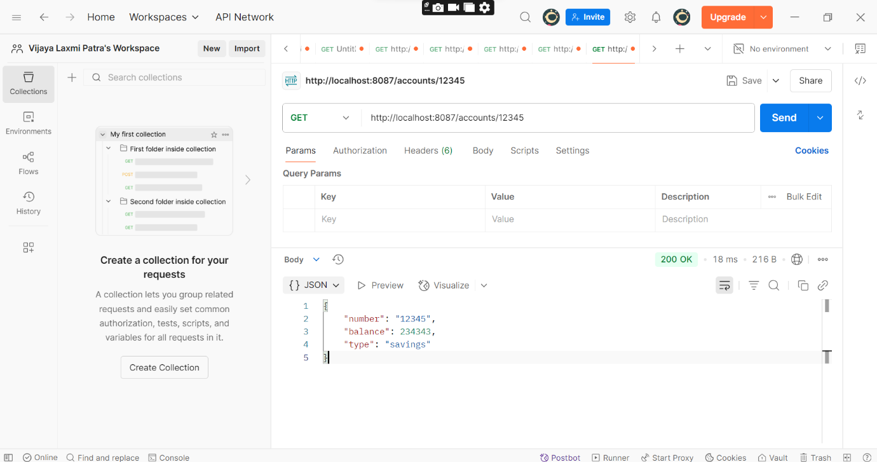

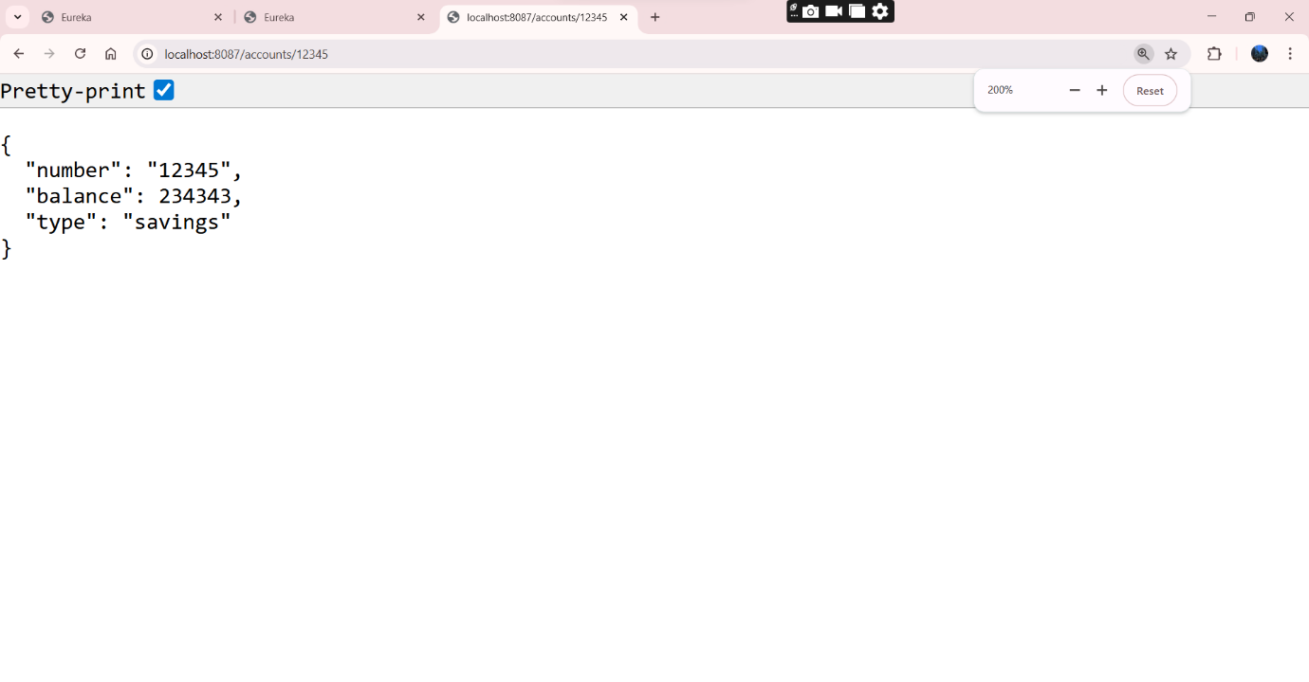

3nd Step: Loan REST API

LoanApplication.java

package com.cognizant.loan;

import org.springframework.boot.SpringApplication;
import org.springframework.boot.autoconfigure.SpringBootApplication;

@SpringBootApplication
public class LoanApplication {

public static void main(String[] args) {
SpringApplication.run(LoanApplication.class, args);
}

}

LoanController.java

package com.cognizant.loan.controller;

import org.springframework.web.bind.annotation.GetMapping;
import org.springframework.web.bind.annotation.RestController;

@RestController
public class LoanController {

@GetMapping("/info")
public String getLoanInfo() {
return "Loan details from Loan Service";
}
}

application.properties

spring.application.name=loan-service
server.port=8085

eureka.client.service-url.defaultZone=http://localhost:8761/eureka/
eureka.instance.prefer-ip-address=true

pom.xml

<?xml version="1.0" encoding="UTF-8"?>
<project xmlns="http://maven.apache.org/POM/4.0.0" xmlns:xsi="http://www.w3.org/2001/XMLSchema-instance"
xsi:schemaLocation="http://maven.apache.org/POM/4.0.0 https://maven.apache.org/xsd/maven-4.0.0.xsd">
<modelVersion>4.0.0</modelVersion>
<parent>
<groupId>org.springframework.boot</groupId>
<artifactId>spring-boot-starter-parent</artifactId>
<version>3.5.3</version>
<relativePath/> <!-- lookup parent from repository -->
</parent>
<groupId>com.cognizant</groupId>
<artifactId>loan</artifactId>
<version>0.0.1-SNAPSHOT</version>
<name>loan</name>
<description>Demo project for Spring Boot</description>
<url/>
<licenses>
<license/>
</licenses>
<developers>
<developer/>
</developers>
<scm>
<connection/>
<developerConnection/>
<tag/>
<url/>
</scm>
<properties>
<java.version>17</java.version>
<spring-cloud.version>2025.0.0</spring-cloud.version>
</properties>
<dependencies>
<dependency>
<groupId>org.springframework.boot</groupId>
<artifactId>spring-boot-starter-web</artifactId>
</dependency>
<dependency>
<groupId>org.springframework.cloud</groupId>
<artifactId>spring-cloud-starter-netflix-eureka-client</artifactId>
</dependency>

<dependency>
<groupId>org.springframework.boot</groupId>
<artifactId>spring-boot-devtools</artifactId>
<scope>runtime</scope>
<optional>true</optional>
</dependency>
<dependency>
<groupId>org.springframework.boot</groupId>
<artifactId>spring-boot-starter-test</artifactId>
<scope>test</scope>
</dependency>
</dependencies>
<dependencyManagement>
<dependencies>
<dependency>
<groupId>org.springframework.cloud</groupId>
<artifactId>spring-cloud-dependencies</artifactId>
<version>${spring-cloud.version}</version>
<type>pom</type>
<scope>import</scope>
</dependency>
</dependencies>
</dependencyManagement>

<build>
<plugins>
<plugin>
<groupId>org.springframework.boot</groupId>
<artifactId>spring-boot-maven-plugin</artifactId>
</plugin>
</plugins>
</build>

</project>

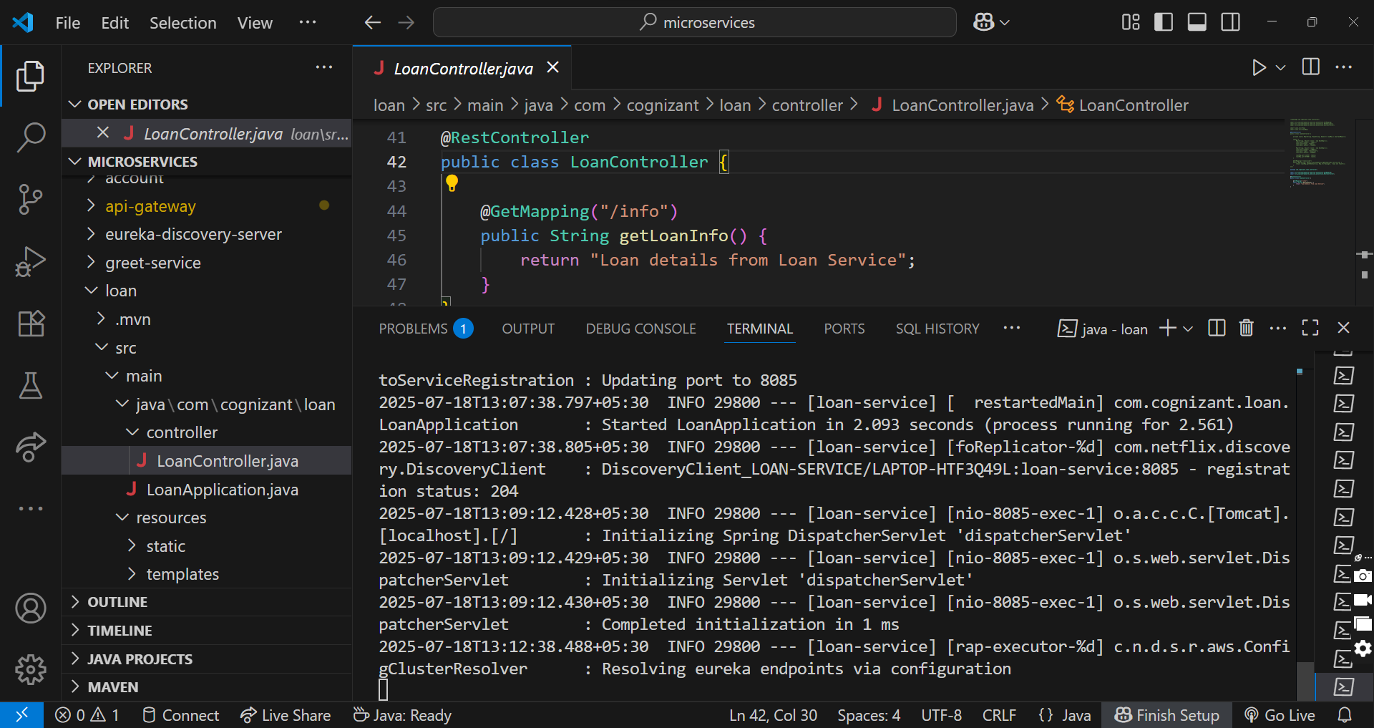

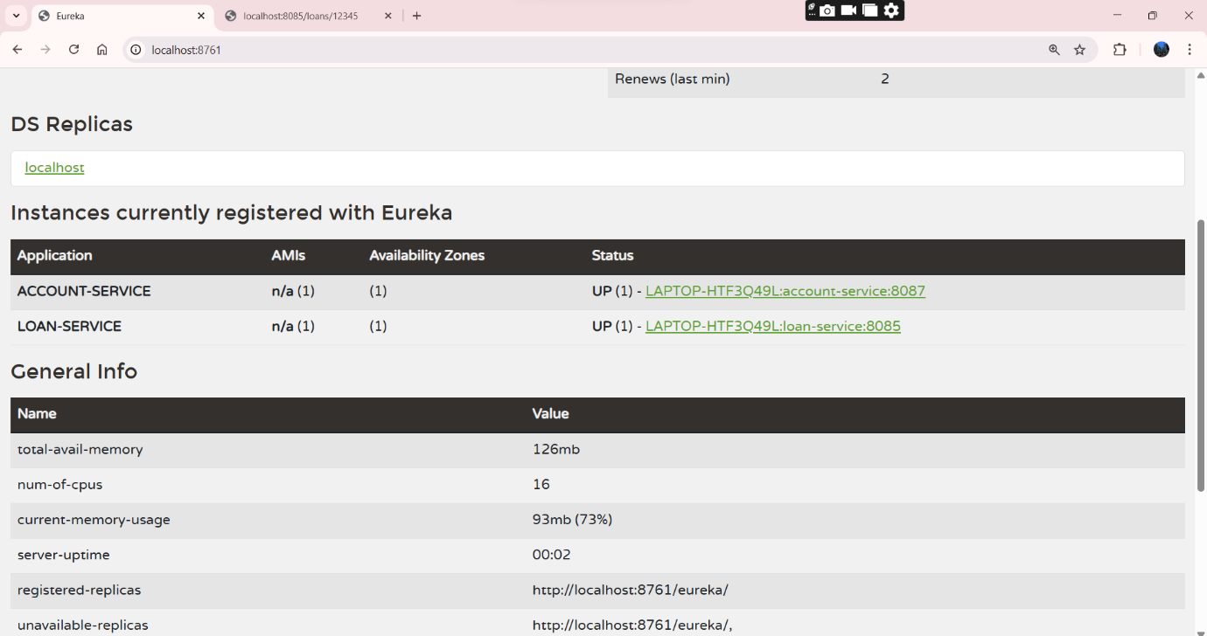

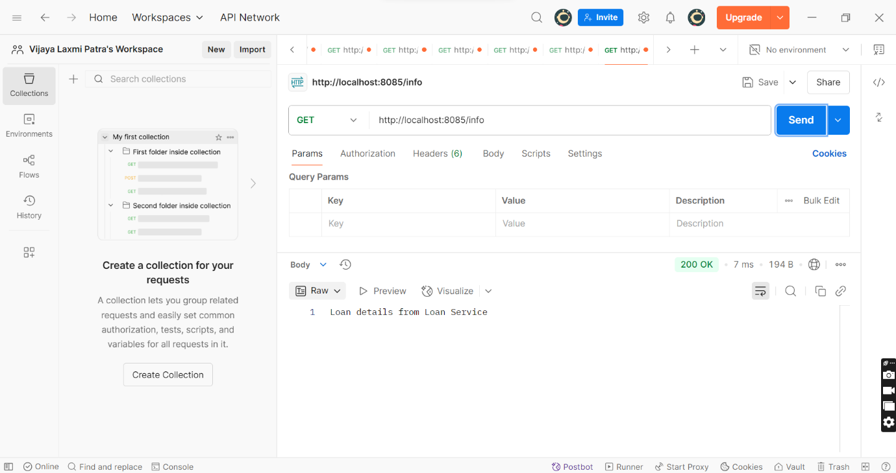

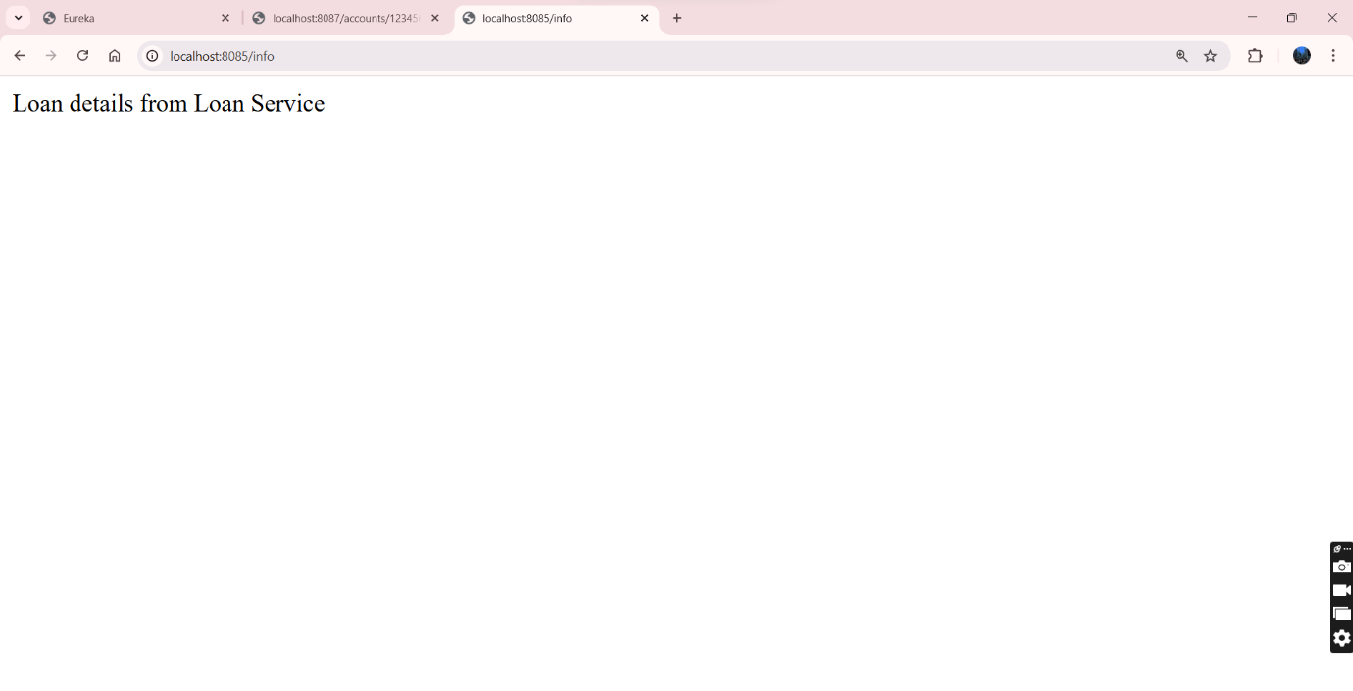

4th Step: Greet Service

GreetServiceApplication.java

package com.cognizant.greet_service;

import org.springframework.boot.SpringApplication;
import org.springframework.boot.autoconfigure.SpringBootApplication;

@SpringBootApplication
public class GreetServiceApplication {

public static void main(String[] args) {
SpringApplication.run(GreetServiceApplication.class, args);
}

}

GreetController.java

package com.cognizant.greet_service.controller;

import org.springframework.web.bind.annotation.GetMapping;
import org.springframework.web.bind.annotation.RestController;

@RestController
public class GreetController {

@GetMapping("/greet")
public String greetUser() {
return "Hello World";
}
}

application.properties

server.port=8082
spring.application.name=greet-service
eureka.client.service-url.defaultZone=http://localhost:8761/eureka/
eureka.client.register-with-eureka=true
eureka.client.fetch-registry=true
spring.main.banner-mode=console

pom.xml

<?xml version="1.0" encoding="UTF-8"?>
<project xmlns="http://maven.apache.org/POM/4.0.0" xmlns:xsi="http://www.w3.org/2001/XMLSchema-instance"
xsi:schemaLocation="http://maven.apache.org/POM/4.0.0 https://maven.apache.org/xsd/maven-4.0.0.xsd">
<modelVersion>4.0.0</modelVersion>
<parent>
<groupId>org.springframework.boot</groupId>
<artifactId>spring-boot-starter-parent</artifactId>
<version>3.5.3</version>
<relativePath/> <!-- lookup parent from repository -->
</parent>
<groupId>com.cognizant</groupId>
<artifactId>greet-service</artifactId>
<version>0.0.1-SNAPSHOT</version>
<name>greet-service</name>
<description>Demo project for Spring Boot</description>
<url/>
<licenses>
<license/>
</licenses>
<developers>
<developer/>
</developers>
<scm>
<connection/>
<developerConnection/>
<tag/>
<url/>
</scm>
<properties>
<java.version>17</java.version>
<spring-cloud.version>2025.0.0</spring-cloud.version>
</properties>
<dependencies>
<dependency>
<groupId>org.springframework.boot</groupId>
<artifactId>spring-boot-starter-web</artifactId>
</dependency>
<dependency>
<groupId>org.springframework.cloud</groupId>
<artifactId>spring-cloud-starter-netflix-eureka-client</artifactId>
</dependency>

<dependency>
<groupId>org.springframework.boot</groupId>
<artifactId>spring-boot-devtools</artifactId>
<scope>runtime</scope>
<optional>true</optional>
</dependency>
<dependency>
<groupId>org.springframework.boot</groupId>
<artifactId>spring-boot-starter-test</artifactId>
<scope>test</scope>
</dependency>
</dependencies>
<dependencyManagement>
<dependencies>
<dependency>
<groupId>org.springframework.cloud</groupId>
<artifactId>spring-cloud-dependencies</artifactId>
<version>${spring-cloud.version}</version>
<type>pom</type>
<scope>import</scope>
</dependency>
</dependencies>
</dependencyManagement>

<build>
<plugins>
<plugin>
<groupId>org.springframework.boot</groupId>
<artifactId>spring-boot-maven-plugin</artifactId>
</plugin>
</plugins>
</build>

</project>

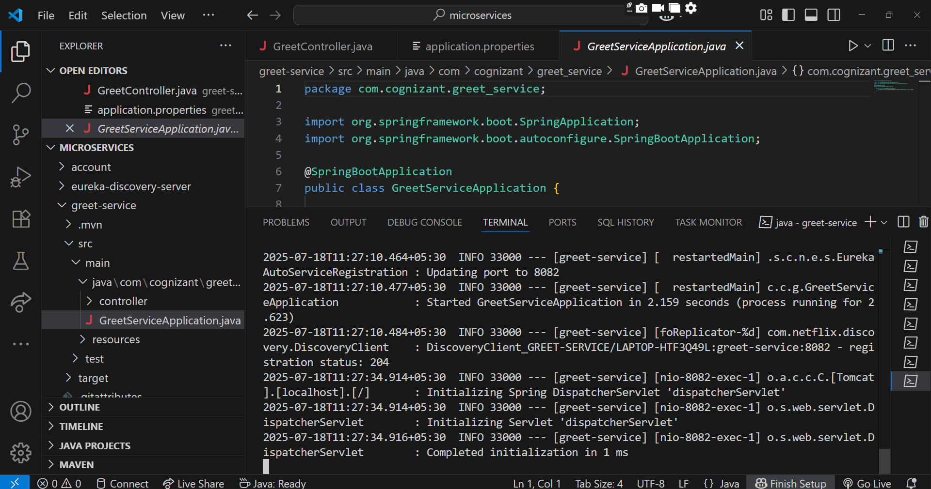

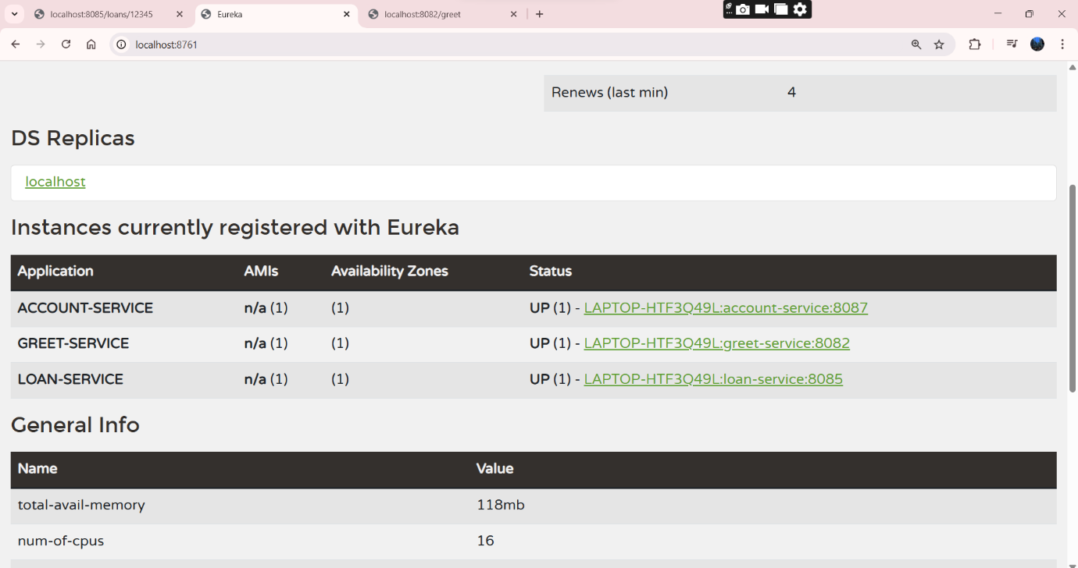

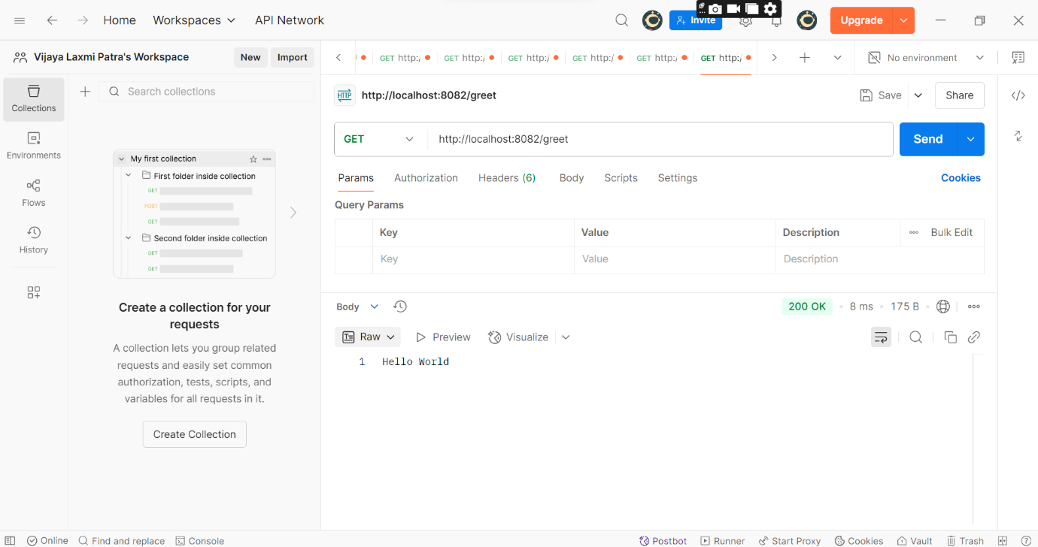

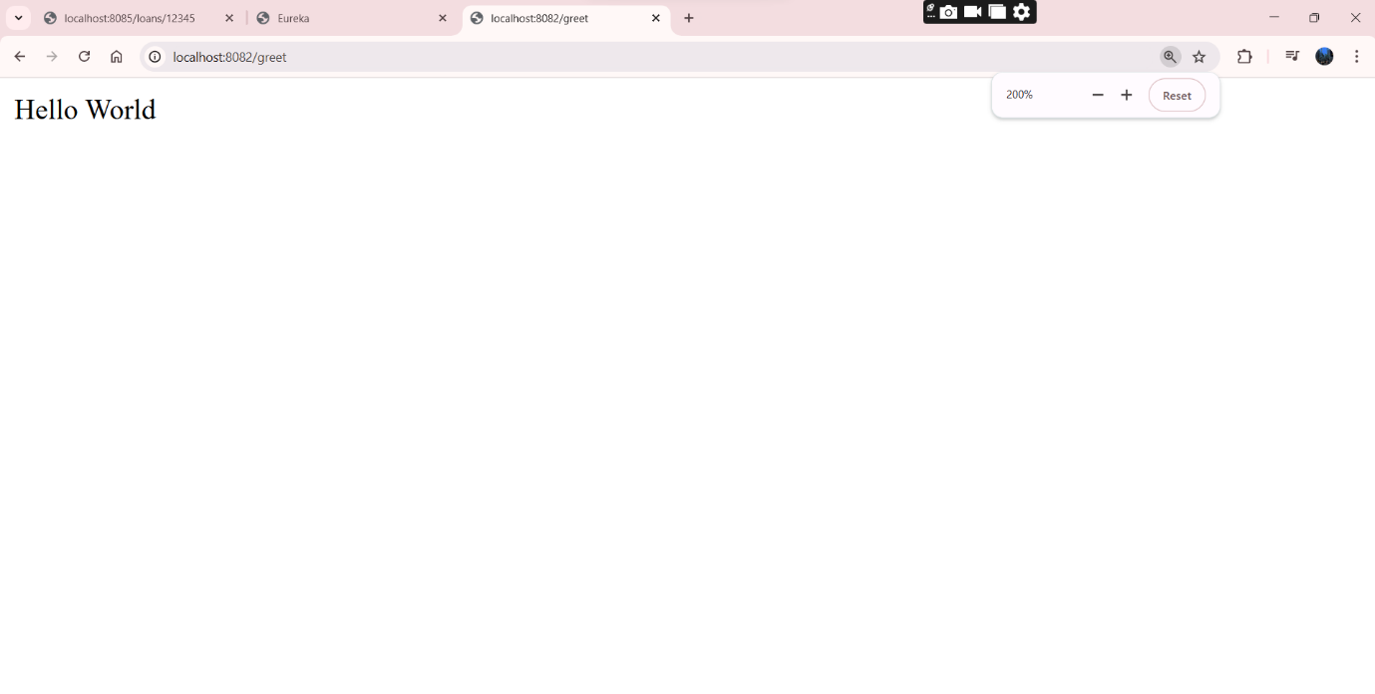

4th Step: API-gateway

ApiGatewayApplication.java

package com.cognizant.api_gateway;

import org.springframework.boot.SpringApplication;
import org.springframework.boot.autoconfigure.SpringBootApplication;

@SpringBootApplication
public class ApiGatewayApplication {

public static void main(String[] args) {
SpringApplication.run(ApiGatewayApplication.class, args);
}

}

LogFilter.java

package com.cognizant.api_gateway.filter;

import org.slf4j.Logger;
import org.slf4j.LoggerFactory;
import org.springframework.cloud.gateway.filter.GatewayFilterChain;
import org.springframework.cloud.gateway.filter.GlobalFilter;
import org.springframework.core.Ordered;
import org.springframework.stereotype.Component;
import org.springframework.web.server.ServerWebExchange;
import reactor.core.publisher.Mono;

@Component
public class LogFilter implements GlobalFilter, Ordered {

private static final Logger logger = LoggerFactory.getLogger(LogFilter.class);

@Override
public Mono<Void> filter(ServerWebExchange exchange, GatewayFilterChain chain) {
logger.info("API Gateway Request -> {}", exchange.getRequest().getURI());
return chain.filter(exchange);
}

@Override
public int getOrder() {
return 0;
}
}

application.properties

server.port=9191

spring.application.name=api-gateway

eureka.client.service-url.defaultZone=http://localhost:8761/eureka/
eureka.client.register-with-eureka=true
eureka.client.fetch-registry=true

spring.cloud.gateway.discovery.locator.enabled=true
spring.cloud.gateway.discovery.locator.lower-case-service-id=true

pom.xml

<?xml version="1.0" encoding="UTF-8"?>
<project xmlns="http://maven.apache.org/POM/4.0.0"
xmlns:xsi="http://www.w3.org/2001/XMLSchema-instance"
xsi:schemaLocation="http://maven.apache.org/POM/4.0.0 https://maven.apache.org/xsd/maven-4.0.0.xsd">
<modelVersion>4.0.0</modelVersion>

<parent>
<groupId>org.springframework.boot</groupId>
<artifactId>spring-boot-starter-parent</artifactId>

<version>3.2.5</version>

<relativePath/>
</parent>

<groupId>com.cognizant</groupId>
<artifactId>api-gateway</artifactId>
<version>0.0.1-SNAPSHOT</version>
<name>api-gateway</name>
<description>API Gateway with Spring Cloud Gateway</description>

<properties>
<java.version>17</java.version>
<spring-cloud.version>2023.0.1</spring-cloud.version>
</properties>

<dependencies>
<dependency>
<groupId>org.springframework.cloud</groupId>
<artifactId>spring-cloud-starter-gateway</artifactId>
</dependency>

<dependency>
<groupId>org.springframework.cloud</groupId>
<artifactId>spring-cloud-starter-netflix-eureka-client</artifactId>
</dependency>

<dependency>
<groupId>org.springframework.boot</groupId>
<artifactId>spring-boot-devtools</artifactId>
<scope>runtime</scope>
<optional>true</optional>
</dependency>

<dependency>
<groupId>org.springframework.boot</groupId>
<artifactId>spring-boot-starter-test</artifactId>
<scope>test</scope>
<exclusions>
<exclusion>
<groupId>org.junit.vintage</groupId>
<artifactId>junit-vintage-engine</artifactId>
</exclusion>
</exclusions>
</dependency>
</dependencies>

<dependencyManagement>
<dependencies>
<dependency>
<groupId>org.springframework.cloud</groupId>
<artifactId>spring-cloud-dependencies</artifactId>
<version>${spring-cloud.version}</version>
<type>pom</type>
<scope>import</scope>
</dependency>
</dependencies>
</dependencyManagement>

<build>
<plugins>
<plugin>
<groupId>org.springframework.boot</groupId>
<artifactId>spring-boot-maven-plugin</artifactId>
</plugin>
</plugins>
</build>
</project>

